BU Assessment Redshift Environment Setup Guide

# Document Information

|  |  |
| --- | --- |
| Author | Kuldeep Sharma, Rameshwar Rao Ericharla |
| Contributors | Suman Kandagatla, Satish Kumar Nampally |
| Date | 02/14/2019 |
| Version | 0.1 |

# Version History

|  |  |  |  |
| --- | --- | --- | --- |
| Version | Date | Author | Changes |
| 0.1 | 02/14/2019 | Kuldeep S | Initial Draft |
|  |  |  |  |

# Purpose

Establish the operational redshift environment for assessment reporting. Redshift database is part of data lake and reporting services for Benchmark Universe. In building the Reporting Service and Reporting UI, the project establishes architecture patterns, such as data ingestion in redshift table and pull the data accordingly for reporting needs or to use in future projects.

# Database Redshift Environment Setup Guide

## Getting Your Connection String

The following procedure shows how to get the connection string that you will need to connect to your Amazon Redshift cluster from SQL Workbench.

**To get your connection string**

1. In the Amazon Redshift console, in the navigation pane, choose **Clusters**.
2. To open your cluster, choose your cluster name.
3. On the **Configuration** tab, under **Cluster Database Properties**, copy the JDBC URL of the cluster.

**Note**

The endpoint for your cluster is not available until the cluster is created and in the available state.

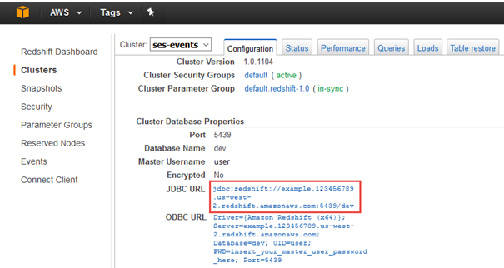

## Connecting to Your Cluster from SQL Workbench

The following procedure shows how to connect to your cluster from SQL Workbench. This procedure assumes that you installed SQL Workbench on your computer.

**To connect to your cluster from SQL Workbench**

To run SQL workbench, java version should be 8 or later. Check java version from command prompt.

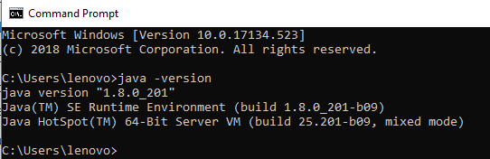

In case java 8 is not installed then install latest java from <https://www.oracle.com/technetwork/java/javase/downloads/jdk8-downloads-2133151.html>

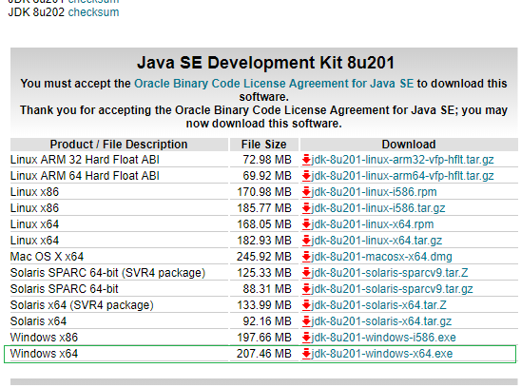

Download SQL Workbench from attachment or from URL <https://www.sql-workbench.eu/downloads.html>



After downloading the zip, unzip and open the folder then click on highlighted application

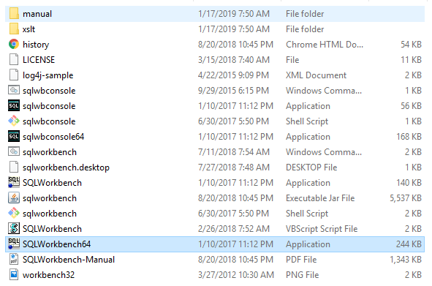

1. Open SQL Workbench.
2. Choose **File**, and then choose **Connect window**.
3. Choose the **Create a new connection profile** button.

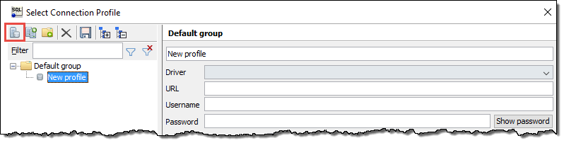

1. In the **New profile** text box, type a name for the profile- name like AWS_Redshift_Connection.
2. At the bottom of the window, on the left, choose **Manage Drivers**.

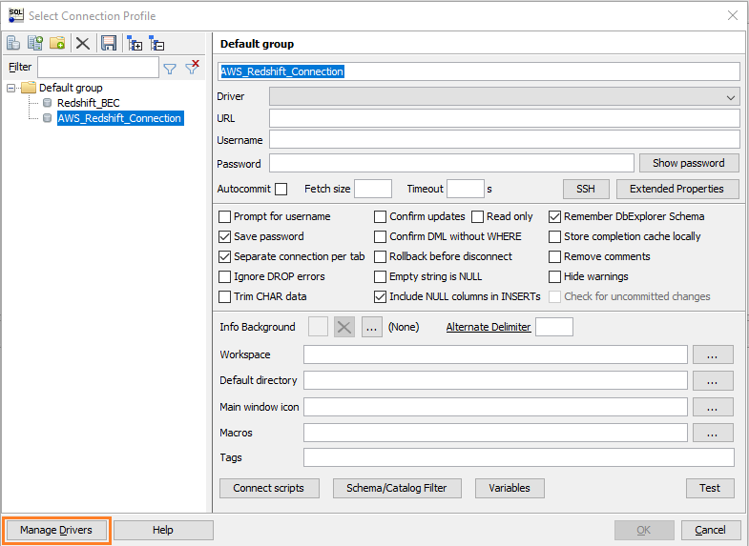

1. In the **Manage Drivers** dialog box, choose the **Create a new entry** button, and then add the driver as follows.

Choose Amazon Redshift from left pan list.

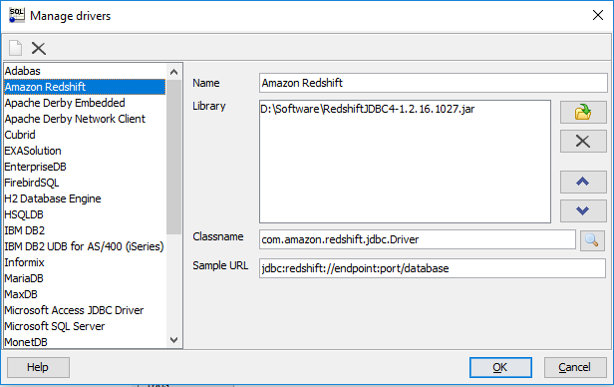

* 1. In the **Name** box, type a name for the driver.
  2. Next to **Library**, choose the folder icon.
  3. Navigate to the location of the driver you downloaded in [Configure a JDBC Connection](https://docs.aws.amazon.com/redshift/latest/mgmt/configure-jdbc-connection.html), select the driver, and then choose **Open**.

You can save the driver (.jar file) from attachment and use.



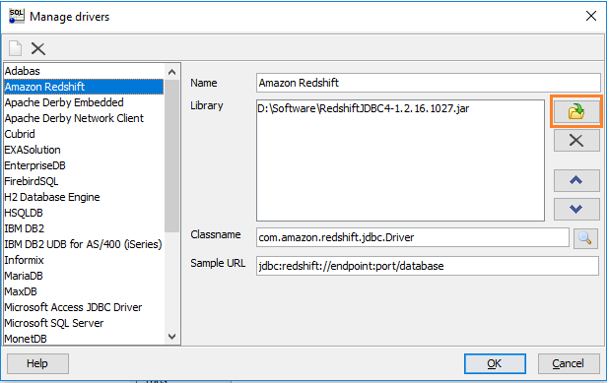

* 1. Choose **OK**.

You will be taken back to the **Select Connection Profile** dialog box.

* 1. Choose Amazon Redshift from Driver Drop down list

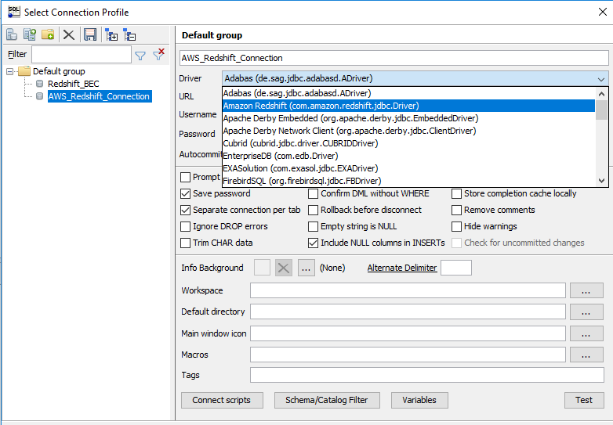

* 1. Copy the end point URL form redshift cluster and past in URL section



* 1. Enter Username and password (get from AWS team) and test.

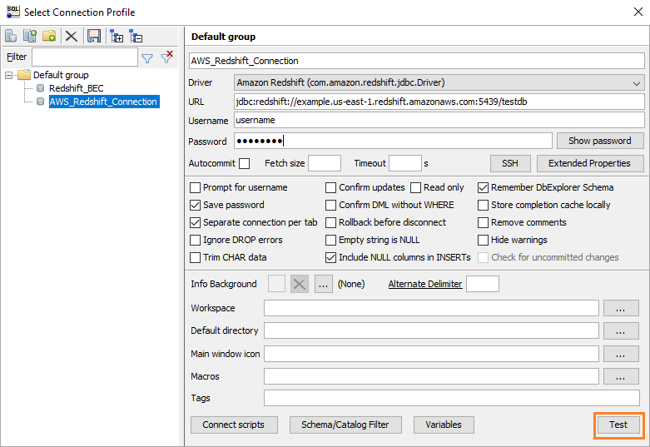

You will be taken to the **Query edition to perform deployment operations**.

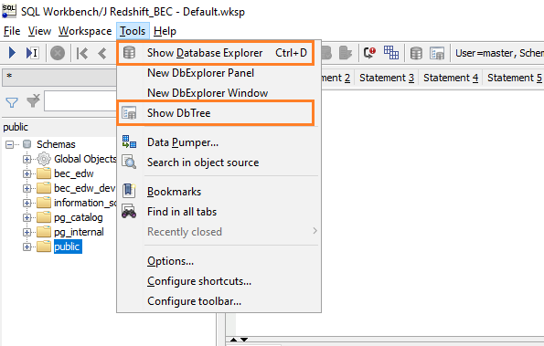

From tools option you can choose Show Db Tree to get all schema related objects. Show Database Explorer will show data, structure and metadata of objects inside the schema

1. Deploy the scripts as provided one by one.

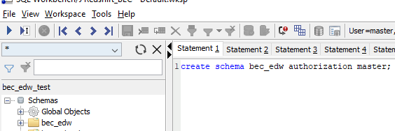

Find all the executable scripts from attachment



Note: Drop statement provided in case if object is already existing in database/schema. If it fails, skip the code and run next.

1. Created object can be verified by left side tree pan.

